User Manual

* Sign Up: If user don't have an account on the DNS Webpage, user can easily create one by providing your credentials.

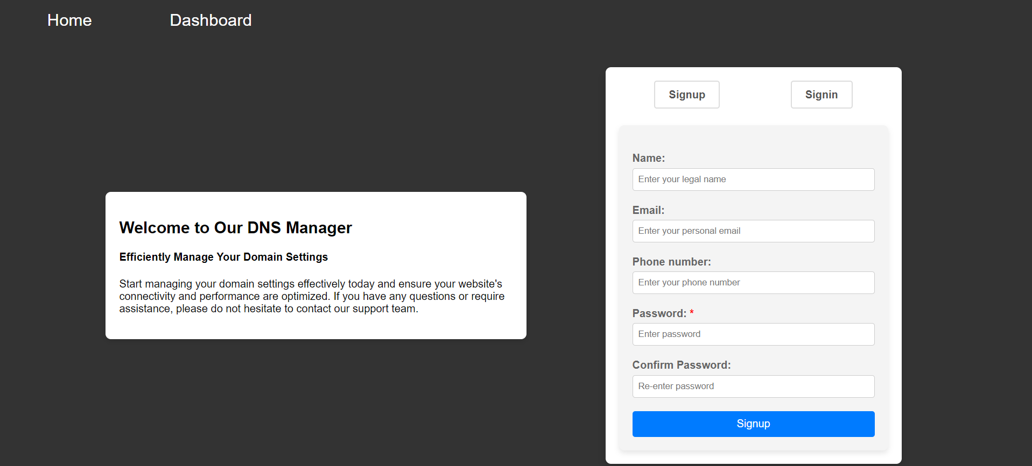

* Login: After Creating account user can login using name and password

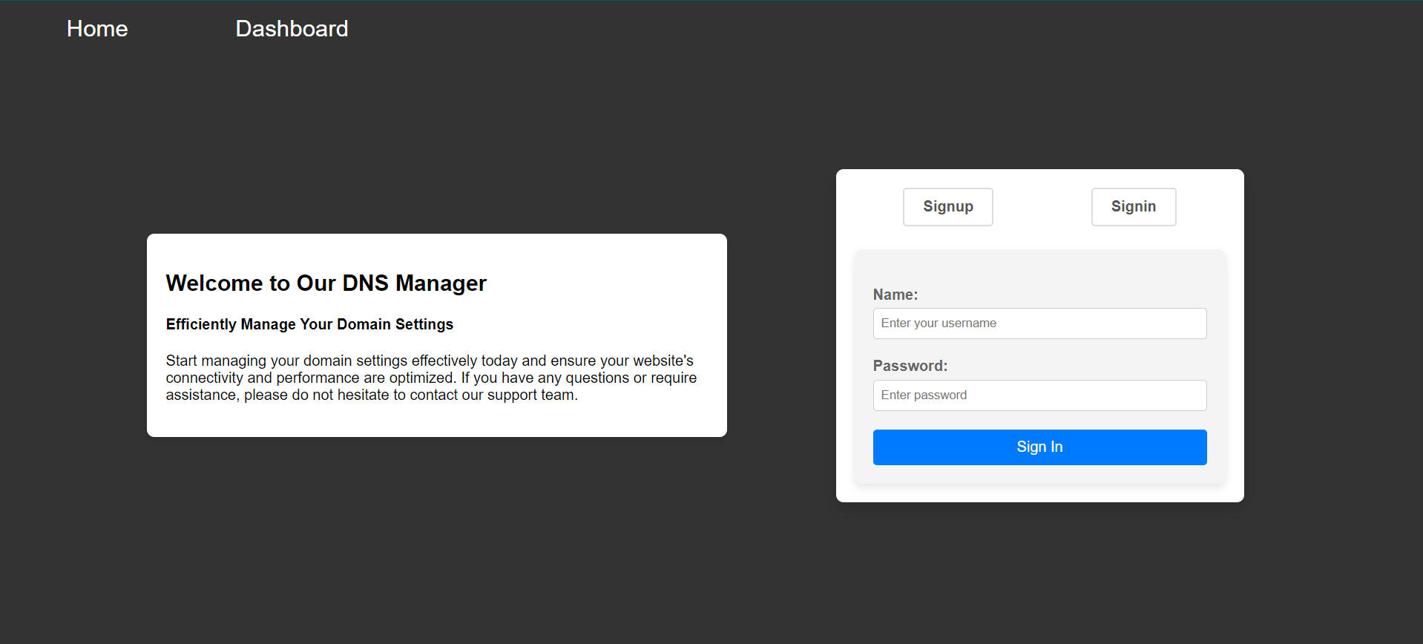

* Home Page: Here user can view records which are already present in aws route 53

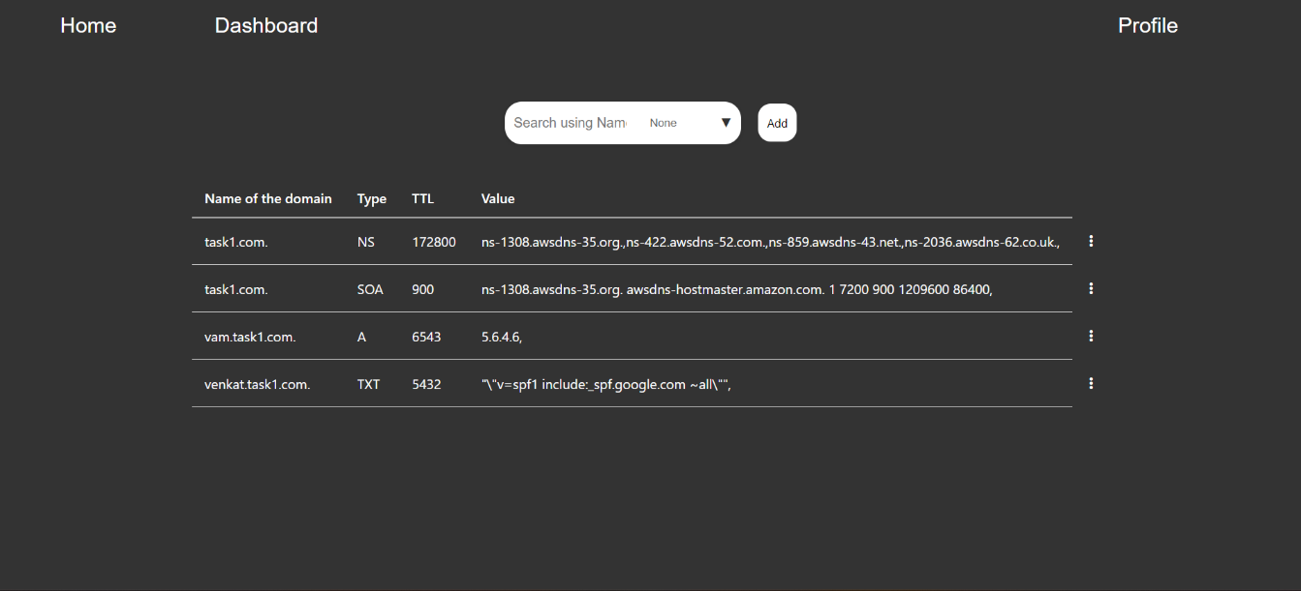

* Filtering and search: If user click on "None," various types will appear. By clicking on the desired type, User filter to view only those records. For searching, simply enter a name in the search bar; the system will automatically search for records by that name.
* Add page: Upon clicking the "Add" button, the user is redirected to the Add page. Here, there are two forms available: one for adding single values and another for bulk additions through file uploads. To add records via the file upload method, the user must upload a file, read its contents, and then proceed to add the records.

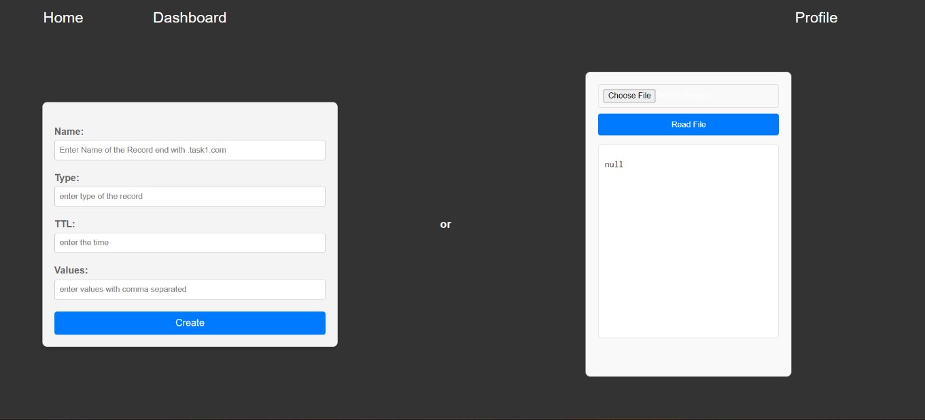

* Editing and deleting: Upon clicking the hamburger menu dots beside the desired row, two options appear: "Edit" and "Delete." If you click "Edit," you will be redirected to the edit page, where you can see a form to edit the values of the record. Clicking "Delete" will remove that record.

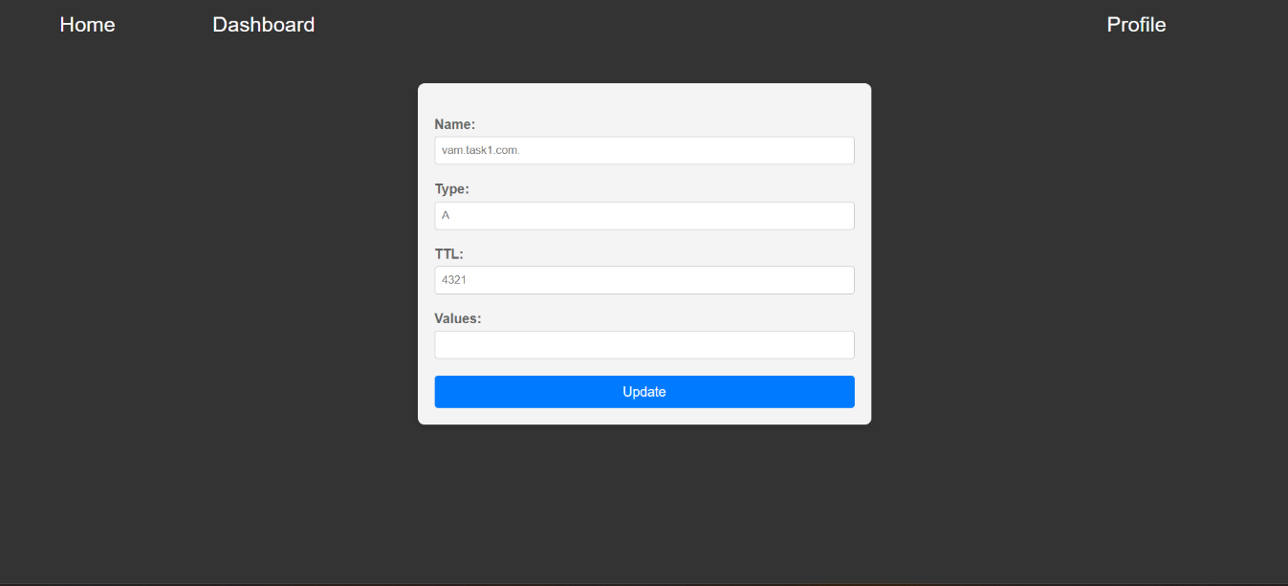

* Dashboard: Upon clicking "Dashboard," the user is redirected to the graph page, where you can view a graph displaying the number of types present in AWS Route 53.

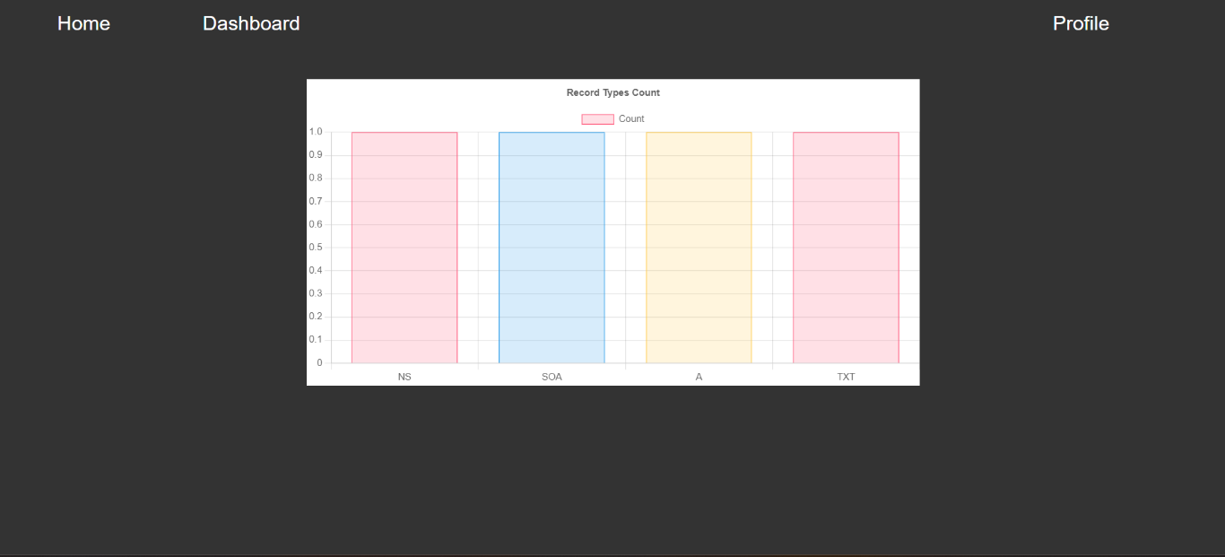

* Profile: Upon clicking "Profile," the user will be directed to the profile page, where they can change their name, update their password, and also log out from the webpage.

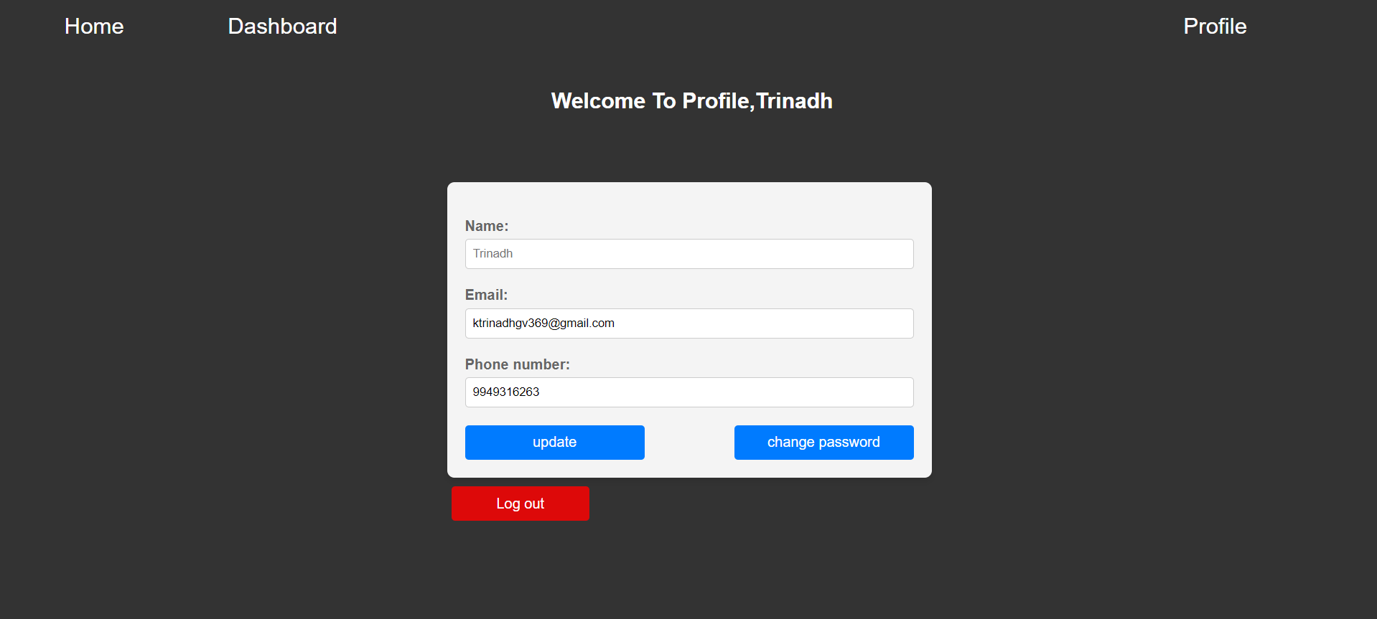

* Updating Password: Upon clicking "Change Password," the user is redirected to the password page, where they will see a form to change their password.

